Arduino Lesson 8
Making Sounds
- Intro
Lots of interactive work can be completed with Arduino , the most common and widely used is the light and sound, the last few projects already show you how LED lights work, this one is to make sounds. Buzzer and speakers these two are very common and can both make sounds, the buzzer is more simple and easy to use than speaker so this experiment we use the buzzer.
- Parts Required
Buzzer x 1
Push Button x 1
Extension Board x 1
Jumper Wires x 1 Bundle
- Connect-it-up
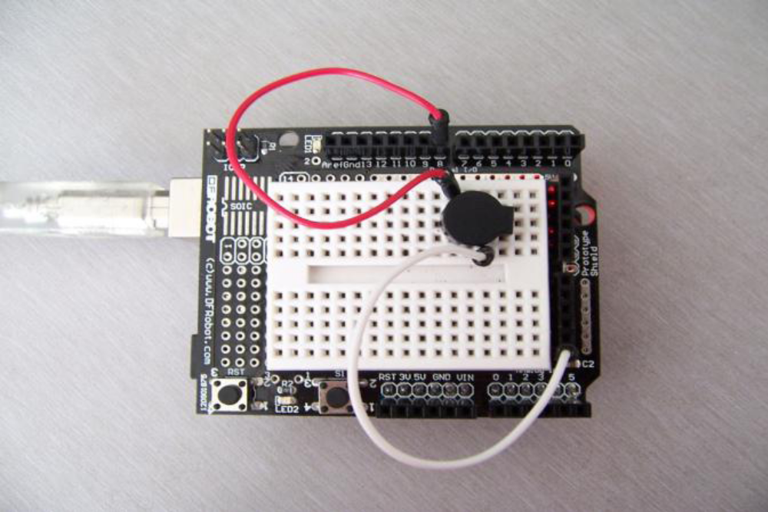
Please note there are positive pole and negative pole on the buzzer.Above picture show you the red and black connections.You can mirror
the connections on push button control light experiment.
- Program for reference
int buzzer=8;//set the digital IO pin to control the buzzer
void setup()
{
pinMode(buzzer,OUTPUT);//set digital IO pin as output mode
}
void loop()
{
unsigned char i,j;//Define variable
while(1)
{
for(i=0;i<80;i++)//Make sound with same frequency
{
digitalWrite(buzzer,HIGH);//Make sound
delay(1);//Delay 1ms
digitalWrite(buzzer,LOW);//No sound
delay(1);//Delay 1ms
}
for(i=0;i<100;i++)// Make sound with other frequency

{
digitalWrite(buzzer,HIGH);//Make Sound
delay(2);//Delay2ms
digitalWrite(buzzer,LOW);//No sounds
delay(2);//Delay 2ms
}
}
}
Download the program, buzzer experiment is done.

